**TITLE: ILLUSTRATION OF VIDEO EDITING USING ADOBE PREMIERE PRO.**

# CONCEPT:

Video editing refers to the process of manipulating and rearranging video shots to create a new work. It involves trimming and arranging video footage, adding transitions and effects, adjusting the color and audio, and other post-production tasks.

Video editing can be done using various software tools such as Adobe Premiere Pro, Final Cut Pro, and iMovie. These tools provide a wide range of features and

functionality to create professional-looking videos. It is an essential part of the video production process. It allows filmmakers, content creators, and other professionals to craft their stories and convey their message in a more engaging and effective way. Video

editing also enables them to fix mistakes, add special effects, and enhance the overall quality of their videos.

Overall, video editing is an art form that requires creativity, technical skill, and attention to detail. With the right tools and techniques, video editors can create compelling videos that captivate and engage their audience.

# TECHNIQUE:

**Step 1: Open Adobe Premier Pro and import any video clip.**

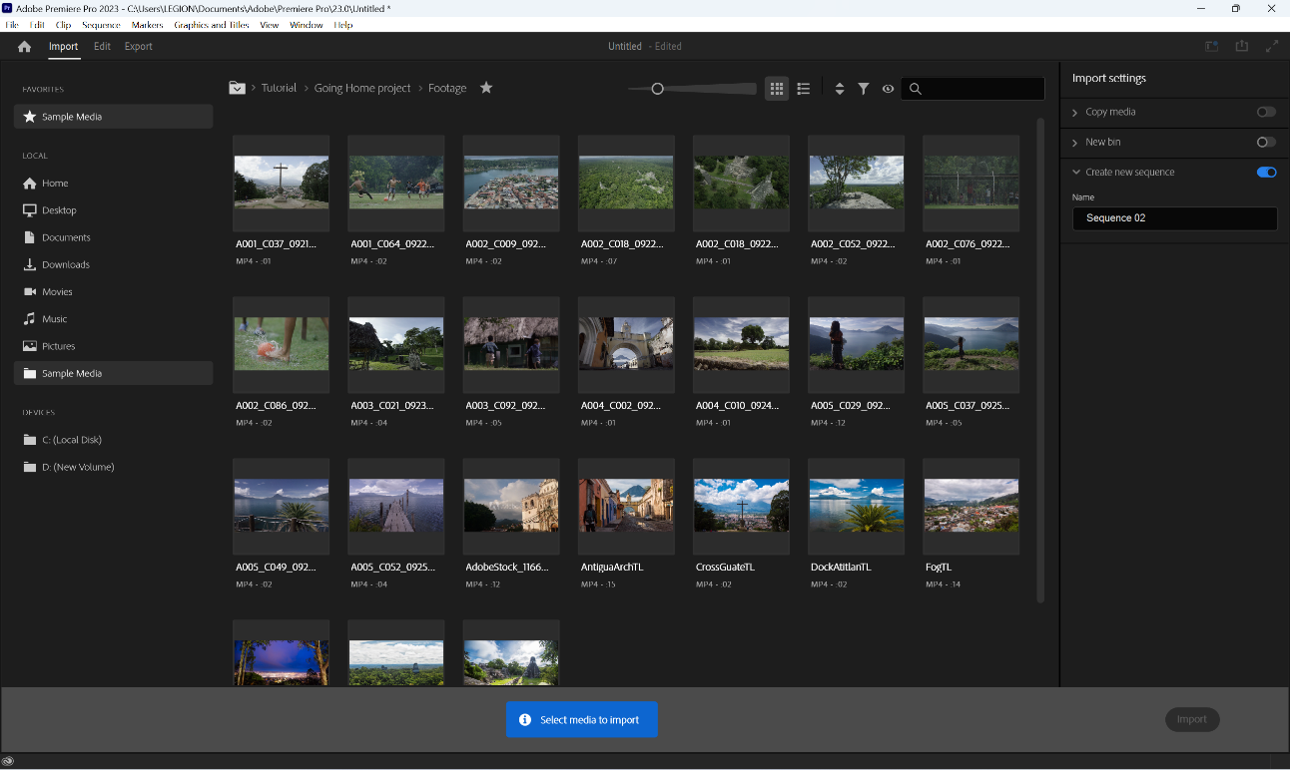

**Step 2: We can add another video clip by drag and dropping in the editing section:**

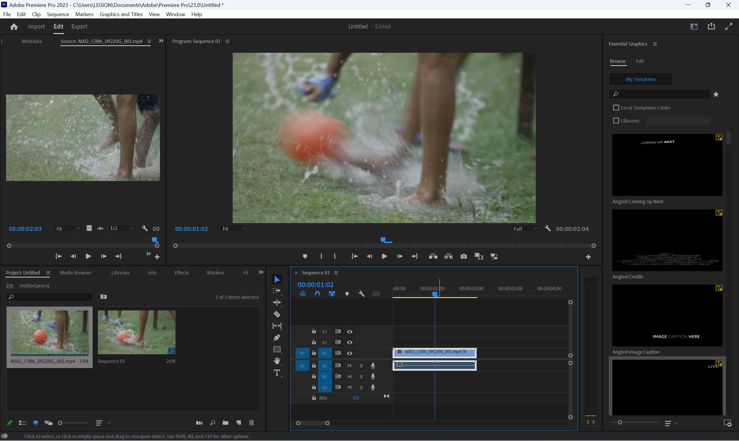

**Step 3: We can trim a portion of the video by using razor tool.**

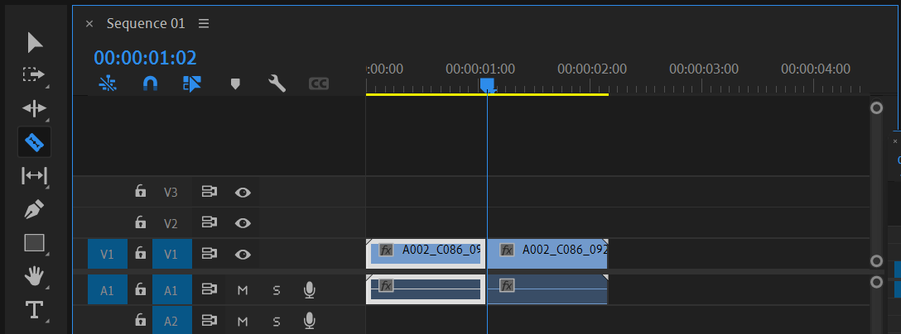

**Step 4: Go to Graphics and Titles, then select layer and text. It helps to give subtitles in the video.**

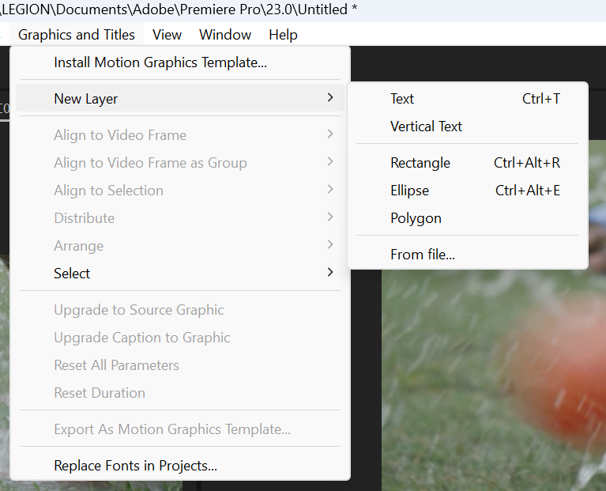

**Step 5: Align the subtitle in the required portion of the video.**

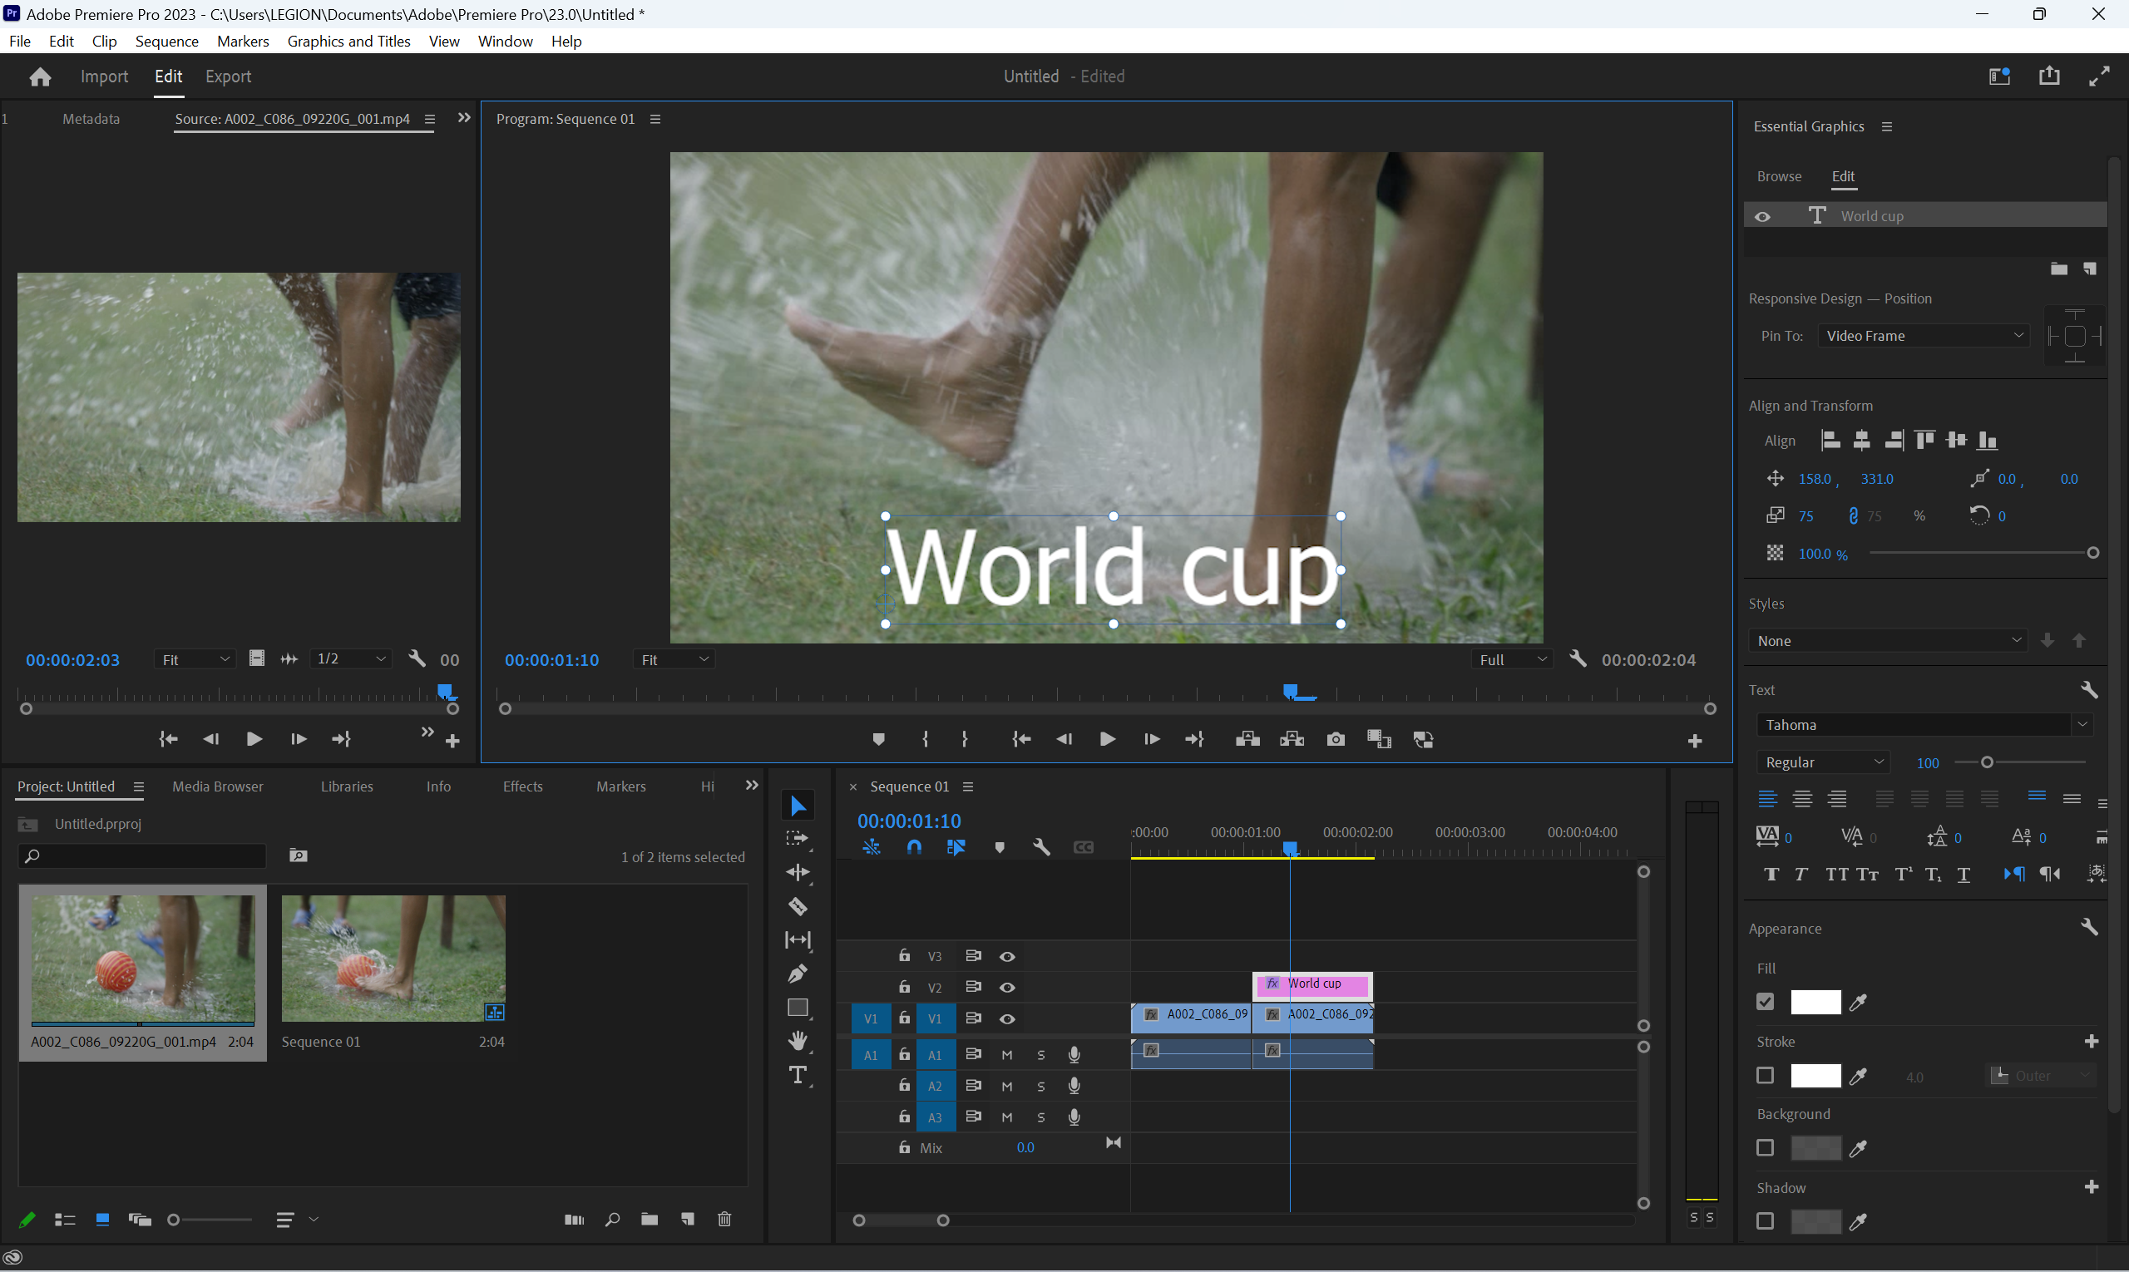

**Output:**

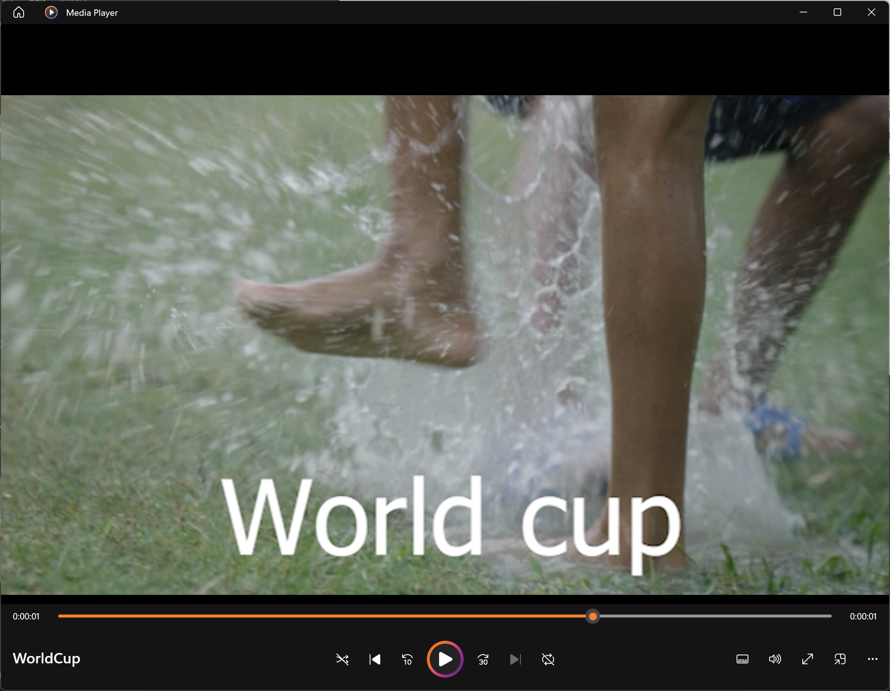

**CONCLUSION:**

In conclusion, we can say that we can edit the videos using Adobe Premier Pro.